Installation and Configuration of SVN Environment

Version 1.0
Date 28/10/10

Copyright notice
Copyright © 2010, Cognizione consulting & solutions Pvt Ltd
All rights reserved.

These materials are confidential and proprietary to Cognizione consulting & solutions pvt
ltd/its licensors and no part of these materials should be reproduced, published, transmitted
or distributed in any form or by any means, electronic, mechanical, photocopying, recording or
otherwise, or stored in any information storage or retrieval system of any nature nor should the
materials be disclosed to third parties without the prior express written authorization of
Cognizione consulting & solutions Pvt ltd/its licensors
Revision history

Doc No: | Version no. | Change reference no. | Author | Published date | Sections changed | Description of changes
 | 1.0 |  | Dikshit | 28/10/10 |  | Base Document

Contents

Contents 3
Purpose of the document 4
Purpose of the document 4
Scope of the document 4
Desired outcome 4
Targeted recipient 4
Prerequisite 4
Required Software 4
Installation Of SVN Server 5
Configuration of SVN Server 5
Testing the SVN Server installation 6
Installation of SVN Client 7
Configuration of SVN Client to use from NetBeans 8
Installation of Tortoise SVN Client 9
Testing successful installation of Tortoise SVN Client 9
Configuring Users 9

Figure 1 :- Setting up the Environment Variable 6
Figure 2 :- Testing SVN Server installation 7
Figure 3 - Configuring SVN client inside netbeans 8

Purpose of the document

This document describes the following

- Installation and configuration of SVN server and SVN client to set up a version control environment.
- Installation of Tortoise SVN Client

Scope of the document

This document only explains the process of installing and configuring the SVN environment as currently set up in Cognizione. It doesn’t explain the following points

- Other modes of configuration through which an SVN environment can be set up.
- Different svn operations like commit, update, branching etc which is covered up in a separate document.

Desired outcome

- Proper installation and configuration of SVN Server.
- Proper installation and configuration of SVN Server.
- Proper installation of Tortoise SVN client.

Targeted recipient

Developers or System Administrators who are in charge of management of the Version Controlling System.

Prerequisite

- Knowledge of window based software installation.
- Setting up of environment variables in windows.
- Downloading Softwares from Internet.

Required Software

The following Softwares are required for the process. These are already available under “D:\Softwares\Versioning” in CCS7 machine and additionally can be downloaded from the url given.

- Collabnet subversion edge – 32 bit (http://www.collab.net/downloads/subversion/)
- Collabnet subversion command line client (http://www.collab.net/downloads/subversion/)

- Tortoise SVN Client – 32 bit (http://tortoisesvn.net/downloads).

Installation Of SVN Server

Being a windows binary package, installation of SVN Server is a straight forward process as explained below.

- Double click on the CollabNet Subversion Command-Line Client v1.6.13 (for Windows).
- Click on “Next” button and follow the instructions for installation.
- The default location of installation will be “C:\Program Files\CollabNet Subversion Server”

Configuration of SVN Server

Follow the following steps for configuring the SVN server

- Right Click on “My Computer” → “Properties” → “Advanced” → “Environment Variables”
- Double click on the “Path” variable under “User Variables” and append to it the full path of the svn installation folder. The default is “C:\Program Files\CollabNet Subversion Server”. If the path variable is not present then create a new variable by the name of “Path” under “user variables”.

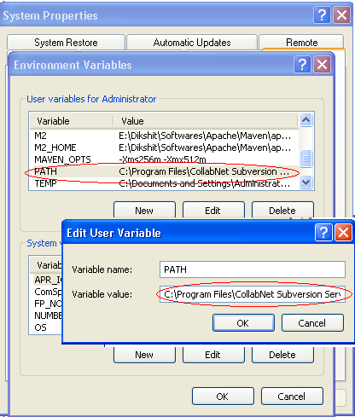
Figure 1 :- Setting up the Environment Variable

Testing the SVN Server installation

To test whether svn server is installed properly, follow the following steps

- Open a command prompt in the machine where SVN Server is installed.

- Type the following command

svn help

and press “Enter” key.

Successful installation should produce the following output
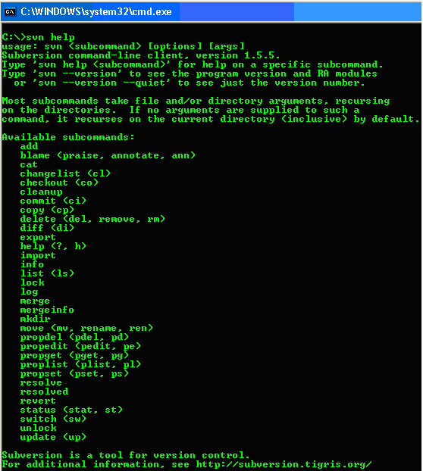

Figure 2 :- Testing SVN Server installation

Installation of SVN Client

Similar to SVN Server, being a windows binary package, installation of SVN Client is also a straight forward process as explained below.

- Double click on the CollabNetSubversion-client-1.5.5-1.win32.

- Click on “Next” button and follow the instructions for installation.
- The default location of installation will be “C:\Program Files\CollabNet Subversion Client”

Configuration of SVN Client to use from NetBeans

Once SVN client is installed in the client machine it has to be configured to be able to use svn operations through NetBeans. The following describes the various steps for configuring the same inside NetBeans.

- Go to “Tools” →”Options” → “Miscellaneous” → “Versioning”

- Click on the “Subversion” tag on the left hand side.

- Update the field “Path to SVN executable file” with the full path where svn client is installed using the browse button, as shown below.

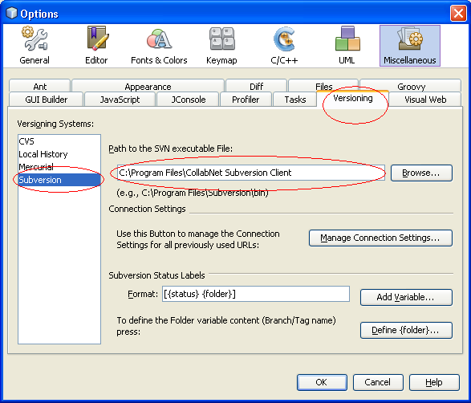

Figure 3 - Configuring SVN client inside netbeans

Installation of Tortoise SVN Client

Follow the following steps for installing Tortoise SVN Client.

- Double click on the “TortoiseSVN-1.5.4.14259-win32-svn-1.5.3.exe” package.

- Click on “Next” and follow the instructions to install.

It doesn’t need any special configuration. All the required configurations are automatically

Testing successful installation of Tortoise SVN Client

It is very easy to test whether Tortoise SVN Client is successfully installed or not as explained below.

- Right click anywhere on the desktop.

- If Tortoise svn client is installed properly then you will see two entries viz. “SVN Checkout” and a multilevel menu “Tortoise SVN”, as shown below

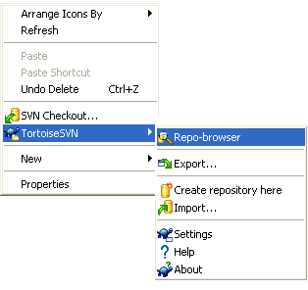

Figure 4 : - Testing proper installation of Tortoise SVN client .

Configuring Users

To configure users follow these steps
- Open the “conf” folder inside the Repository
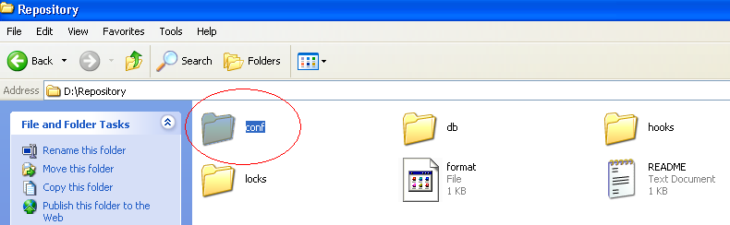

Figure 5 : conf folder inside Repository

- Inside the “conf” folder “select the file passwd → Right Click → Select EditPlus3” to open the file in EditPlus

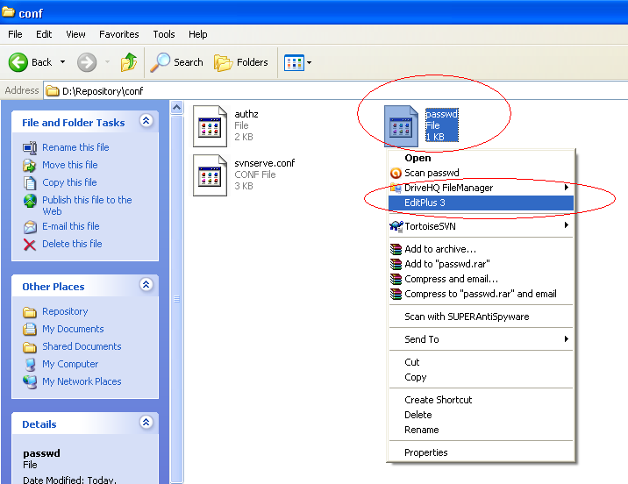

Figure 6 : Selecting the passwd file for opening

- User name and passwords are stored inside this folder in the form of “user name = password” as shown below

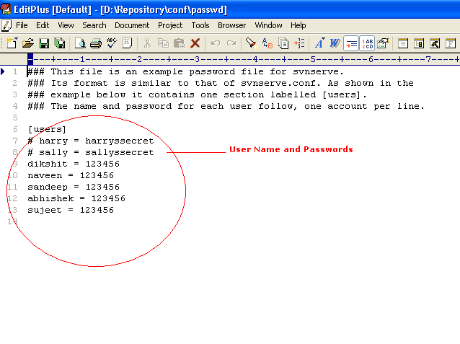
Figure 7 : User name and password

- Open the file “svnserve” in the same folder, in EditPlus and uncomment the following two lines (by removing #)

anon-access=read
auth-access=write
password-db = passwd
realm = My First Repository

